**Paper review of:   
Multi-Contrast Super-Resolution MRI Through a Progressive Network**

* Gives a summary of the application domain of the paper

A summary of the application domain of this paper would be the use of a one-level non-progressive neural network and a two-level progressive neural network to sample multi-contrast super-resolution (SR) MRI images. The non-progressive network is used for low up-sampling and the two-level progressive network is used for high-up sampling.

The paper has three main contributions which will be described to give more detail:

1) The Wasserstein generative adversarial network with gradient penalty(WGAN-GP) architecture which is used in the two-level progressive neural that can obtain excellent MCSR results with the use of a high up-sampling factor

2) When combining multi-contrast information in a high-level feature space leads to a significantly improved results over the combination in the low level pixel space

3) The contribution of a composite loss function including the mean-squared-error (MSE), perceptual loss and a texture matching loss to ensure that the generated images are able to recover texture details and are faithful to the ground truth.

The methodology summary is divided in five sections.

In section 1 the **overall super-resolution process** is described. In their previous single-image super-resolution study a deep learning framework to achieve MRI SR imaging with complementary image priors. The amount of prior information gathered from single-contrast images is limited. For multi-contrast images for MRI SR imaging an advantage is taken, because the multi-contrast images contain more prior information than single-contrast images. A deep learning-based MCSR method for SR T2 weighted imaging is used by incorporating high-resolution proton density (PD) or T1 weighted images as reference images.

In section 2 **down-sampling and zero-filling** is described to produce low resolution (LR) images. By down-sampling and zero-filling the image size is unchanged but the image quality is degraded.

In section 3 the **one-level non-progressive network** is described. The network is also based on the WGAN-GP, which includes a generator and discriminator. The generator consists of an encoder which has eight sequential convolutional layers, each of which is followed by a rectified linear unit (ReLu). The generator also consists of a reference feature extraction network.

In section 4 the **objective function** is described. The function includes four parts:

1. The **adversarial loss** in the generative adversarial network framework is used to train the generator.
2. The **Mean-Squared Error** evaluates the difference between the output of the generator and the corresponding ground truth at pixel-wise level. It can greatly improve the signal-to-noise ratio of generated images.
3. The **perceptual loss** overcomes the problem that some details may be lost due to over-smoothed SR results. The perceptual loss recovers more details.
4. The **texture matching loss** contributes to generate an image with great similarity between the output of the generator and the ground truth by statistically matching extracted features.

Section 5 is about the **two-level progressive network**.

The image quality **evaluation metrics**

* Discusses the strong and weak points of the methodology and evaluation metrics

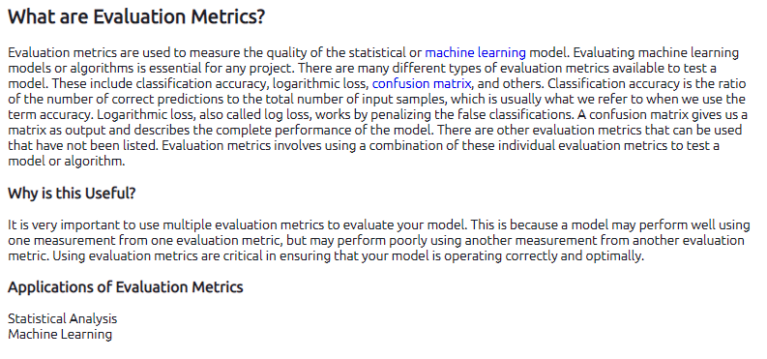

* Suggests alternative methodology, evaluation metrics and ideas for improvement
* Although MSE leads to a high signal-to-noise ratio in reference to the ground truth, it tends to produce over-smoothed SR results. Therefor they also use perceptual loss. **Is there a way to combine these to so you’re not firstly creating a problem and then solving it with another loss function.**
* Also two distorted images with the same MSE may have very different types of errors, some of which are much more visible than others. One error might be preferred over the other which is now not addressed with the use of MSE.
* PSNR is no longer regarded as a reliable indicator of image quality degradation [1]. Although a higher PSNR generally indicates that the reconstruction is of higher quality, in some cases it may not. Bear in mind that none of these objective measures are particularly good at predicting human visual response to image quality. Sometimes PSNRs vary wildly between two almost indistinguishable images. SSIM is recommended. So since this is already used we propose just skipping PSNR.
* The Cognitive Interaction Problem. It is widely known that cognitive understanding and interactive visual processing (e.g., eye movements) influence the perceived quality of images. For example, a human observer will give different quality scores to the same image if s/he is provided with different instructions [1].

[1] <https://ece.uwaterloo.ca/~z70wang/publications/ssim.pdf>